Activity 1(28.09.2026)
1.Introduction to mobile computing - a basic cellular system cellular network concepts -frequency and interface in cells

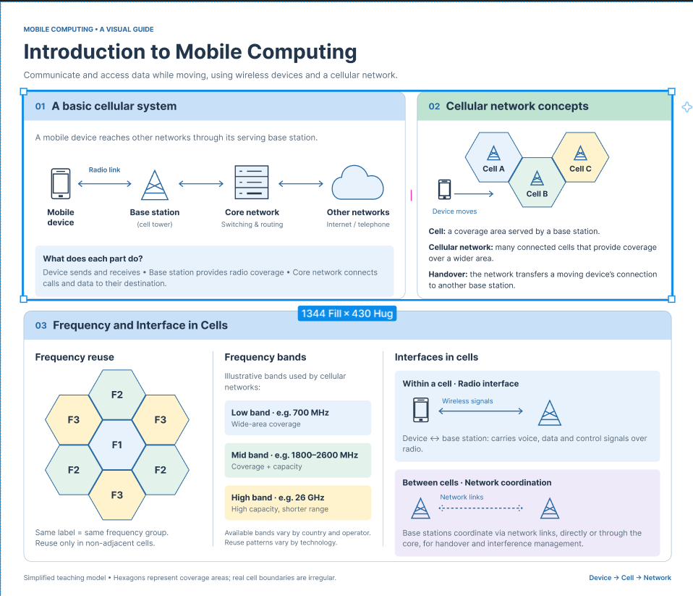
2.Use Figma to create an interactive diagram illustrating the components of a basic cellular system.
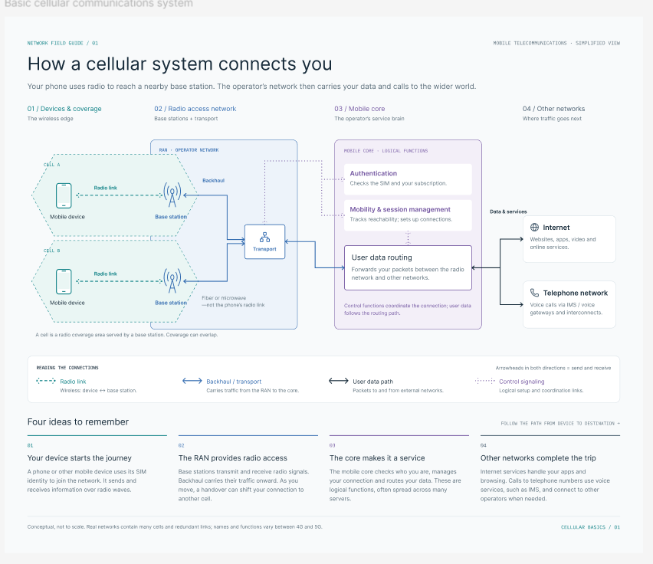
Design a user interface prototype for a mobile station using Figma, considering connectivity and convenience.



